

NAMIBIA UNIVERSITY OF SCIENCE AND TECHNOLOGY

FACULTY OF COMPUTING AND INFORMATICS

INTRODUCTION TO COMPUTER

GROUP ASSIGNMENT

ParticipantS:

NSABIMANA jean claude: 218106831

Selma nangombe shigwedha: 221046607

Alweendo paulus : 221122478

John negumbo: 220129932

Andreas tuyenikelao n: 221085831

APPLICATION NAME

Ayisha beauty management SYSTEM

AYISHA BEAUT MANAGEMENT SYSTEM

1.INTRODUTION

Ayisha beauty was establish on 16th of September 2000 by Jean Claude Kamanjab village-based manufacturer in the Beauty,. Ayisha beauty offers the following products. Personal Care and Cosmetic sector. Every innovative beauty tool, texture, formula, and cosmetic colour makes your life easier, more fun, and uniquely beautiful. Our products deeply moisturize, strengthen, stimulate growth, and radiate a natural glow for all hair and skin textures. Our female team has joined together, and we have not stopped developing new ways to transform your beauty routine. We are listeners and problem solvers working to empower all beauty users’ lives, it is what sets us apart. Our product range is distributed by Dischem Pharmacies Namibia and PnP Namibia Stores.

2. DESCRIPTION OF CURRENT SITUATION

With a current system in Ayisha beauty, a customer goes to the reception then an employee will give the form. A customer must fill the form with all information or detail that are riquired. A customer has the right to ask all information about the service and the cost at the reception. An employee gives a product hand in hand then

PROBLEMS IDENTIFIED

* Customers don’t know the product we sell.
* customers take a long time to pay because of the queue.
* The employees do not get payment on time.

The system should able able to fixe or to solve the identified problems at Ayisha beauty. The first possible solution is to create a software sytem. So that it can help to store the details for customers,employees and products.It can help in edit, delete and format the customer details when is required.

The second possible solution is to create a system for online enquiries. This sytem would help the customer to find more information about the Ayisha beauty and to pay their amount online. This sytem can help to avoid the problem for standing long time at the place and it would **reduce the queue.**

7.SEPARATION MODULES

Customers module

Products module

ORDER MODULE

Employee module

CUSTOMER MODULE

This module contains all the information for the customer such as customer given names, customer ID, product type, payment method.

ORDER MODLE

It contains information of customers who ordered the products.

Given names, product name, product type, place, delivery date,payment method.

Customer mooodle

FUNCTIONS

Var customer={

first names;

last name;

Customer ID;

Product type;

Payment method;

Display function(){

Customer( first name, last name, ID, product type,payment method)

Return function;

}

PSEUDOCODE

(customer module)

1. Start
2. Enter first_Name
3. Enter Last_Name
4. Enter ID_Num
5. Enter product_name
6. Enter product_type
7. Select payment_method
8. If payment_method = 1 then
9. Display cash
10. Else
11. payment_method = 2 then
12. Display electronic transfer
13. Endif
14. Endif
15. End

FLOWCHART

Enter first _name

Enter last_name

Enter product_name

Enter product_type

1=CASH

2= EFT

1 2

EFT

CASH

PRODUCT MODULE

Product module contains the product details and user precaution. Product ID, Product name,Product type, color, weight,smell, size,design.

Var product={

Product ID;

Product name;

Color;

Weight;

Smell;

Seize;

Design;

Display function(){

Product(this ID,this name, this color,this weight,this smell,thissize;this design,

}

Pseudocode

(product module)

1. Start
2. Enter product_name
3. Enter Product_type
4. Enter color
5. Enter weight
6. Enter size
7. Enter design
8. End

START

Product_name

Product_type

color

weight

size

design

END

EMPLOYEE MODULE

This module contains all the information for the emplyees.

Employee ID, given names, date of birth, joined date,skill,salary, nationality and so on .

Funcions

Take care of the the Ayisha beauty products.

Offer good servise to the customers.

Do daily routine work

PSEUDOCODE

(EMPLOYEE MODULE)

1. Start
2. Enter Employee_ID
3. Enter First_Name
4. Enter Last_Name
5. Enter skill
6. Enter salary
7. If salary < N$ 1o ooo then
8. Print paid
9. Else
10. Print(‘’error”)
11. else
12. Print(‘’well done’’)
13. Endif
14. End

START

Employee ID

FIRST NAME

LAST NAME

SKILL

SALARY

Salary<10000

PAID

ERROR

END

PSEUDOCODE

(ORDER MODULE)

Given names, product type, place, delivery date,payment method.

1. Sart
2. Enter first_name
3. Enter surname
4. Enter cell_number
5. Enter email_address
6. Enter product_name
7. Enter product_type
8. Enter place
9. Delivery date
10. Payment
11. If payment = cash then
12. Display CASH
13. Else
14. Display EFT
15. Endif
16. End

START

FIRST NAME

SURNAME

CELL NUMBER

EMAIL ADDRESS

PRODUCT NAME

PRODUCT TYPE

PLACE

DELIVERY DATE

PAYMENT

PAYMENT=EFT

PAYMENT=CASH

NO YES YES

CASH

EFT

END

Employee form

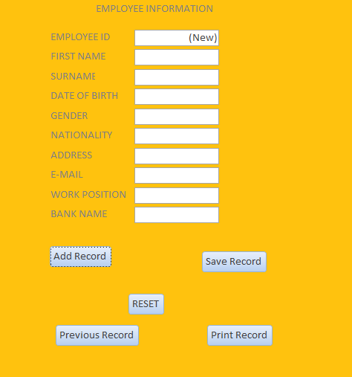

Customer/client form

